**Minecraft:**

Minecraft was the game which inspired the simplistic emergent-behavior based A.I for the villagers and authority. Old Minecraft “mobs” (enemy ai) has simplistic instructions which basically randomly tell the NCP to face a direction and sometimes walk forwards.

The villager NPC in our game will be very similar to this in that when they are wandering, they will randomly look in directions and walk. The Authority AI will be chasing the player and sometimes turning in an attempt to avoid obstacles.

**What can be learnt from the game:**

Minecraft’s old simplistic enemy A.I behavior shows that very simple rules in a procedural environment can emerge as seemingly natural and believable behaviors.

**Image example:** 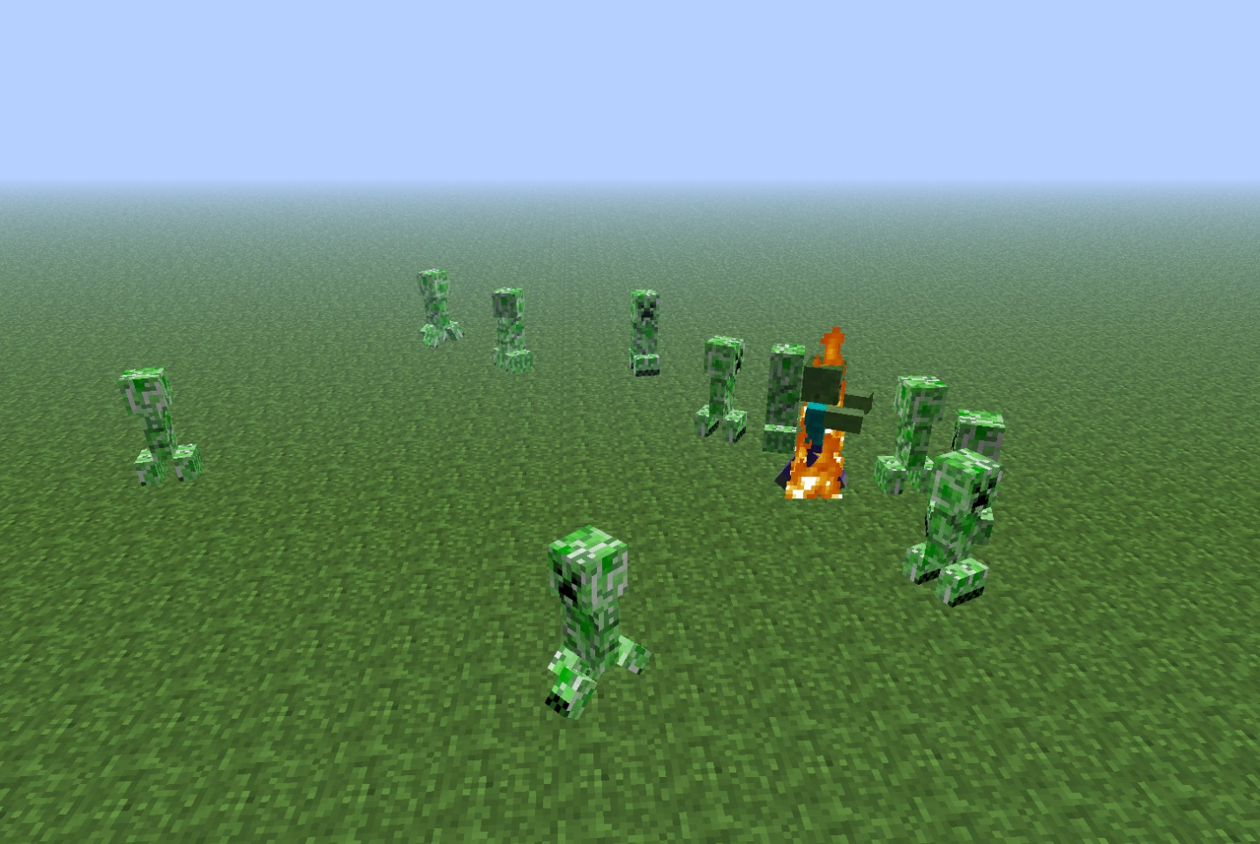

**Thrasher: Skate and destroy (PS1):**

“Thrasher: Skate and destroy” inspired the mechanic of an authority NPC chasing the player when they are spotted and reported. Skate and destroy is a skate-boarding game in which you need to do as many stunts as you can, while trespassing on private property and while under a time limit. Once your time limit runs out, an authority NPC will spawn and chase you down. Once catching you, the level is over.

The authority mechanic in our game will be very similar to this, when the player is spotted, an authority NPC will spawn and chase them down. Apon reaching the player, the player will be killed and the playthrough is over.

**What can be learnt from the game:**

“Thrasher: Skate and destroy” ‘s level ending mechanic of an authority chasing the player is an immersive and realistic way of ending a level under a time limit as apposed to simply just ending the level as soon as the time is up. It allows the player to attempt to recover from a mistake or make up for poor time management without feeling too easy.

**Video example:** <https://www.youtube.com/watch?v=eO-RfyqKGUo> **(Video documentary about the game, see timestamp 4:10 for authority example)**

**Team-fortress 2:**

Team-fortress 2 inspired the mechanic of stalking and executing/attacking an enemy from behind. In Team-Fortress 2, you can play as the class “spy”. This class has a knife as their primary weapon. When a spy is behind an enemy, they can attack the enemy killing them instantly using the knife to stab them in the back.

The back-stabbing mechanic in Team-Fortress 2 inspired the attack-from-behind mechanic in our game.

**What can be learnt from the game:**

The back-stabbing mechanic in Team-Fortress 2 is an example of how the process of attacking an enemy can be made to require specific environmental variables, such as being behind the enemy. This can be done with quite simplistic and fast mathematics, however, can result in a semi-realistic and challenging method of killing enemies in a video game. It forces the player to act in methodic and stealthy ways which is perfect for stealth-based gameplay.

**Video example:** <https://www.youtube.com/watch?v=gh5Fg5d_uBU&t> **(Video illustration of the mathematics behind the Team-Fortress 2 spy back-stabbing mechanic)**